Personal Website Project – Matthew Rushton

# Purpose

The personal website project is to have a demonstration of ability to use HTML and CSS to create a website. The website will also serve to provide potential employers or customers with a visual portfolio of my work.

# Features

The website uses bootstrap responsive design for the overall layout, serving to provide a nice visual presentation to all users regardless of screens size.

The site also features a table for the resume and a feature that allows the overflow of the table to scroll. While this does not fit the responsive design parameters specifically, it does allow the responsive design to function correctly while still allowing mobile users to view the site correctly.

The site uses a navigation bar across the top that will collapse when the screen size is reduced. The logo will also swap to a mobile friendly image when this occurs.

Footer section contains the links to navigate through the site as well as social media icon links that link to actual social pages.

There is a guestbook that allows users to provide feedback and let me know they were at the site.

# Pages

There are a total of five pages. They are:

* Home.html
* Interest.html
* Reflections.html
* Resume.html
* Guestbook.html

Each page has a footer with navigation and a navigation bar across the top.

CIS 241 Final Website Pages

Home.html

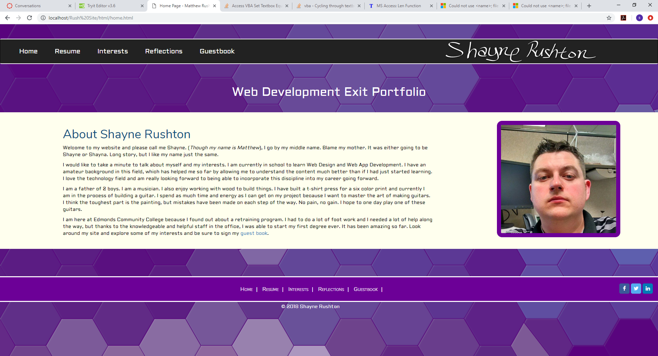

Resume.html

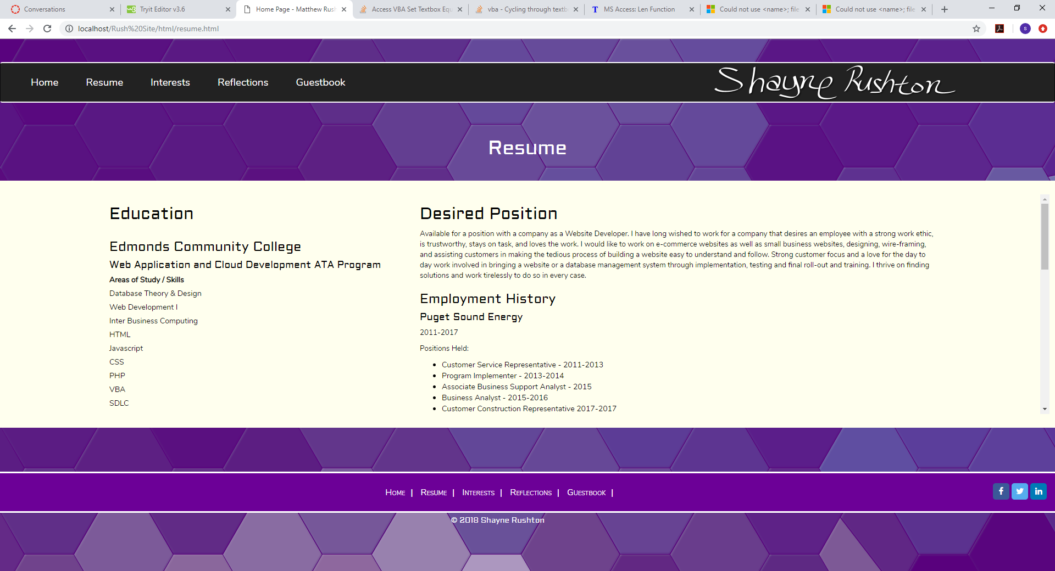

Interests.html

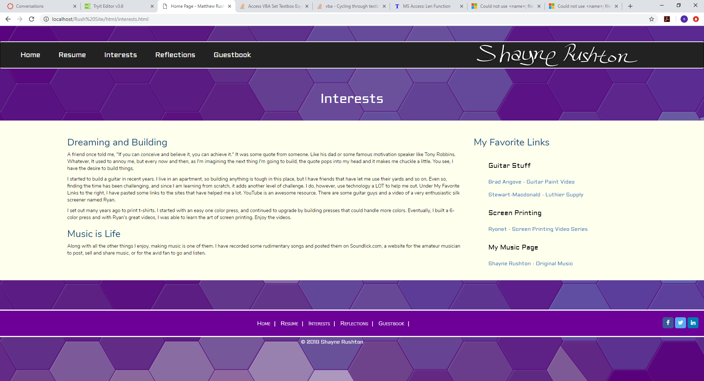

Reflections.html

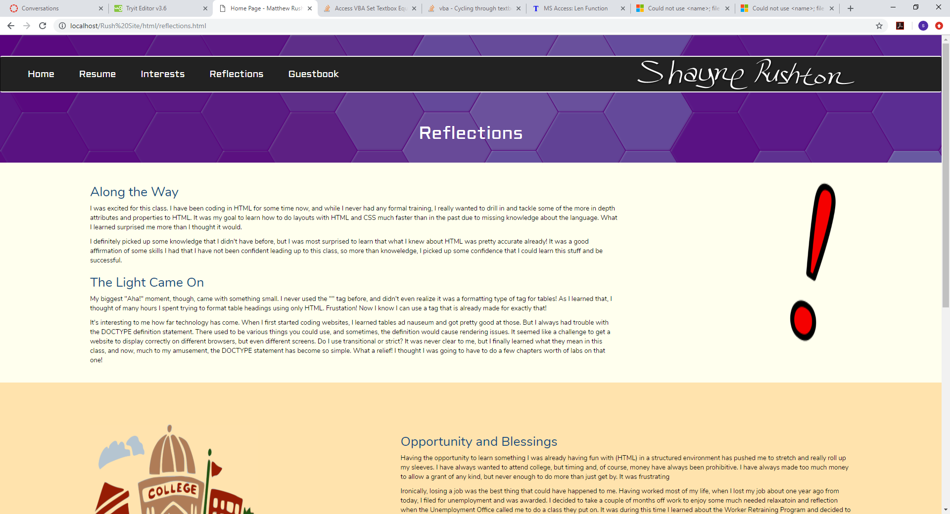

Guestbook.html

